Chapter 6

Quality Management and International Standards

**Background**

This chapter contains almost no quantitative material (most is reserved for Supplement 6). Nevertheless, any introductory operations management course absolutely must cover this content. Total quality management has become institutionalized in many firms around the world. If we quit teaching it, though, the perceived importance of the concepts will fade over time.

The evolution of quality management practices in business has a fascinating history. The ideas have been around since World War II, but western firms did not pay any attention to them at the beginning. In fact, there’s an old black and white British film called, “Right First Time,” that contains many of the concepts that still appear today in modern books about quality management. Having not had much luck with U.S. companies, W. Edwards Deming took his quality philosophies to Japan, which was devastated in the aftermath of World War II. Hungry for survival and growth, Japanese firms latched onto his ideas and added some of their own. By the 1970s, in relative obscurity, Japanese firms in numerous industries began producing products with higher quality than their western counterparts. Finally in the 1980s, western firms woke up to the fact that they were in trouble and finally started to look at the Japanese philosophies and the work of Deming and others. Now as we progress into the 21st century, high quality has become an order qualifier in many industries, and quality management programs have finally become ingrained in most top organizations around the world. The requirement of ISO 9000 certification to be even considered a supplier for numerous customers worldwide is one example of this quality evolution. Nowadays, buzzwords like “JIT,” “lean operations,” “six-sigma programs,” and “Toyota production system” (see Chapter 16)—have numerous similarities with, and roots derived, from the total quality management philosophies developed decades ago.

It seems important when discussing Chapter 6 to award due credit to the Japanese for essentially forcing the rest of the world to adopt total quality management programs to survive. There’s an old story from the *Toronto Sun* that can be summarized as follows: “IBM decided to have some parts manufactured in Japan as a trial project. In the specifications, they set the limit of defective parts at three units per 10,000. When the shipment arrived from Japan, it included this letter: ‘We Japanese have hard time understanding North American business practices. But the three defective parts per 10,000 have been included and are wrapped separately. Hope this pleases.’” Clearly, this story gets to the heart of the “zero defects” philosophy championed by the Japanese, as compared to an “acceptable quality level,” which has been historically common in U.S. firms. Another very important concept (which is easy to talk about but difficult to implement) attributable to the Japanese and Deming is the idea that defects, when they do exist, represent an opportunity for problem solving as opposed to a mistake that should be hidden. Deming believed that 80-85% of quality problems are caused by management, not the workers, so the identification of a defect is an opportunity for management to fool-proof that system in the future. A third concept attributable to the quality pioneers is the idea that it can be possible to have high quality and low cost at the same time. Spending more money on prevention is assumed to save even more than that on failure costs; therefore, “quality is free” (Crosby), and firms should strive to make it “right the first time.”

**Class Discussion Ideas**

1. To many people, high quality is synonymous with high price or high cost. Pick two functionally similar products that compete in very different markets and have the students discuss the relative quality of each. One possible pair is a Toyota Corolla and a Rolls Royce. This is a good way to demonstrate that cost is often a function of the market requirements and high quality can be achieved at any cost point.

2. An effective way to begin this lecture can be to ask the simple question: “What is quality?” As quality means different things to different people for different products and services, within about 10 minutes students will usually develop a list that includes most or all of Garvin’s eight dimensions of quality: Performance, Features, Reliability, Conformance, Durability, Serviceability, Aesthetics, and Perceived Quality (and later researchers added a 9th dimension: Safety).

3. An effective way to end this lecture can be to ask the question: “How can a university control the quality of its output (that is, its graduates)?” This exercise allows the students to vent a little bit (sometimes the instructor needs a thick skin if the comments hit too close to home). Students typically bring up some interesting points, though, and blame gets spread around to faculty, staff, and the students themselves. Interestingly, most of the recommendations would create a financial burden (in the form of higher cost or lost revenue), which makes the choice of which ones to implement a difficult one for university administration. Improving quality at a university does not seem to be as straightforward as it might be for a manufacturing firm.

**Active Classroom Learning Exercises**

1. Five, five-station assembly lines using students could be created that produce, say, a product built out of legos. The dreaded *yellow* lego might represent a defective component. Inspection points could be set up at a different station on all five lines. The defective component is not detected until it reaches the inspector. Any product with a defect must be either scrapped or sent back to the first station for repair and replacement of the component. The metric to compare the assembly lines might be raw material costs (where fewer raw materials are wasted when inspection occurs after the first station) or productivity (where more final products make it through when inspection occurs after the first station). The phenomenon will be exacerbated if units are made in lots of 10 units before passed on to the next station (particularly if the defect is introduced to each unit in the lot). Instructors can be creative with this exercise. The main point, of course, is that catching a defect at its source is much less costly than catching it later on, especially if it reaches the final customer without being noticed.

2. Split the class into small groups. Assign each group a company that is not the industry leader (with each group working on a different industry). The task is to improve quality for each company, and one of the tools to achieve that will be benchmarking. Have each group identify recommended items to benchmark and the companies or industries to obtain that information (it is important for students to recognize that benchmarking does not have to look only at other firms in the same industry). How will all of the data be obtained? Have each student group report its ideas to the whole class.

3. Have the students look at the OM in Action box: “Richey International’s Spies” at the end of Chapter 6. Ask them to count the number of occurrences of the letter “e” in the box—this is a surrogate for 100% inspection. Offer $5.00 to the first student to provide the correct number (only one attempt per student), and produce a distribution on the board as each student yells out the answer. It is unlikely that anyone will get the correct answer.

**Company Videos**

1. *The Culture of Quality at Arnold Palmer Hospital (10:18)*

Arnold Palmer Hospital emphasizes two quality tools in particular: Pareto charts and flow charts. The hospital has several process improvement teams in place, and it seems to take quality extremely seriously. A detailed questionnaire is mailed to *every* patient two weeks after her stay. The most important question for the hospital is, “Would you recommend this hospital to family and friends?” Survey results drive new quality initiatives and process change, when indicated. The hospital consistently performs in the top 10% nationwide on patient satisfaction. And, as an obviously crucial measure of quality for any hospital, Arnold Palmer Hospital has one of the highest survival rates for at-risk babies. The hospital employs two rather unique quality initiatives. First, employees are empowered to offer gifts up as much as $200 to patients that appear to have a legitimate concern about the quality of care that they have received, whether it be medical, food-related, custodial, etc. Second, patients have access to a 24-hour hotline that connects them to hospital staff specifically on call to address any type of patient concern.

Prior to showing the video, instructors might ask the students to write down any memorable service level experiences that they or their families or friends have had at hospitals. Discussion following the video could first cover some of these. For negative experiences, in particular, the instructor might ask if the hospital had any of the quality programs that Arnold Palmer Hospital does, or what else those hospitals might have done, if anything, to address the patient concerns. Two other discussion streams could emerge. First, what do students think of the $200 service recovery gift program? How closely should such a program be micro-managed? Is it a good idea to empower all staff members to award the gifts? Would training be necessary to help employees know what level of gift is appropriate? Second, why should such a large and high-demand hospital care so much about quality? Is high quality affecting its profit in the short run? In the long run? What might be some ramifications of focusing more on cost control and less on patient satisfaction?

2. *Quality at the Ritz-Carlton Hotel Company (7:34)*

The Ritz-Carlton has a goal of 100% customer satisfaction. The company won the Malcolm Baldrige National Quality Award in 1992, and quality has been the center of everything that the hotel does ever since. The process improvements implemented during the time leading up to the Baldrige award led to numerous positive ramifications. There are 20 Ritz-Carlton “basics,” which are instilled in every employee. One of those basics is “MRBIV,” which stands for mistakes, rework, breakdowns, inefficiencies, and variation. MRBIV visits each hotel in the chain from time to time, and employees strive to create programs that respond effectively to MRBIV and that keep MRBIV from arriving in the first place. The company collects a large amount of data every day, emanating from customer surveys, employee reports, and financial measures. Lists of top defects are compiled from the daily quality production reports, and then initiatives are developed to keep those defects from occurring again. Hourly employees are trained in TQM tools, and the hotel uses a lot of self-directed work teams, which perform some traditional management tasks such as scheduling workers. The firm has found that the employee empowerment created by these self-directed teams has helped its quality efforts tremendously. Employee ideas are encouraged, and a cost-benefit analysis is employed to determine the viability of those ideas.

Prior to showing the video, instructors might ask the students to write down any memorable service level experiences that they or their families or friends have had at hotels or motels. Discussion following the video could first cover some of these. For the negative experiences, in particular, how did the staff respond? Did it seem that providing a high-quality service was the top priority of staff members at that hotel? Two different discussion streams about the Ritz-Carlton quality program might emerge. First, the instructor might ask the students about potential downsides of using self-directed work teams? Will they work in every company or industry? If not, what might be some pre-conditions that would make them successful? Second, using cost-benefit analysis in a service business might be more difficult than it sounds. For example, if a new idea makes customers happier but costs $5 more per customer, how do we measure the benefit of “happiness?”

**Cinematic Ticklers**

1. *Gung Ho, (Michael Keaton and Gedde Watanabe), Paramount Pictures, 1986*

If not shown with Chapter 2, scenes from this movie highlight the Japanese “zero-defect” policy and other Japanese business practices.

**Presentation Slides**

INTRODUCTION (6-1 through 6-8)

Slide 8: Arnold Palmer hospital does so much more than just “going through the motions” with these quality tools. The hospital really ingrains a culture of quality in all of its employees. Patient satisfaction is truly the number one priority. The results clearly reflect this culture: (1) the hospital typically scores in the top 10% nationally in benchmark patient satisfaction surveys, and (2) it boasts one of the highest neonatal intensive care survival rates in the U.S.



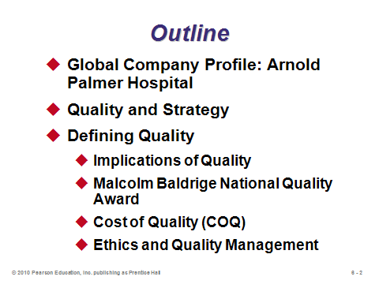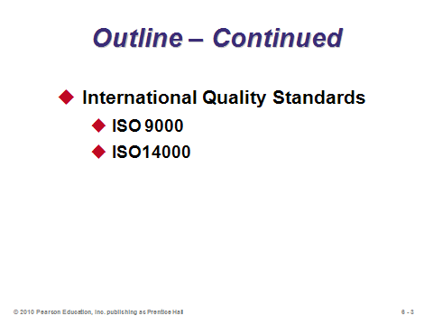

**6-1 6-2 6-3**

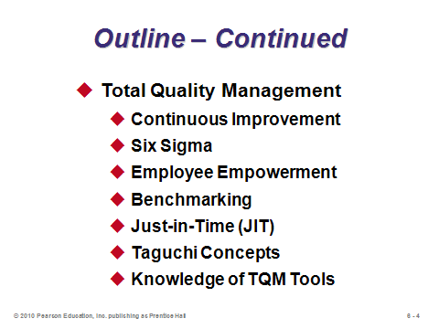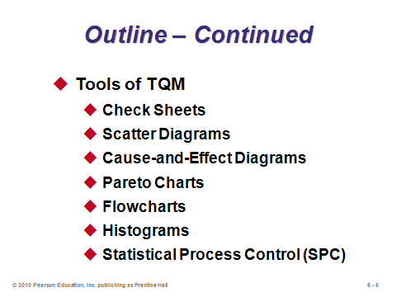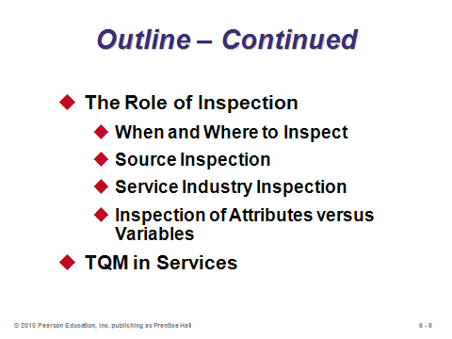

**6-4 6-5 6-6**

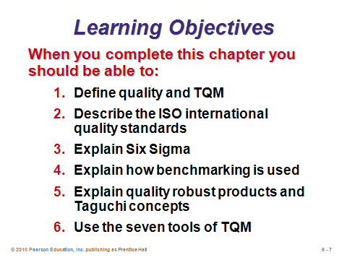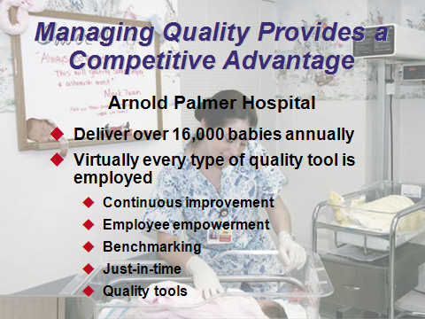

**6-7 6-8**

QUALITY AND STRATEGY (6-9 through 6-12)

Slides 9-10: Right away the instructor can emphasize that “high quality” is not an exclusive strategy unto itself. On the contrary, the pursuit of high quality can actually support other strategies discussed in Chapter 2 by satisfying customer needs or making things run more smoothly or cheaply. It *is possible* to have high quality and low cost at the same time! For the third bullet—this is something that all of the quality gurus recognize. A successful quality management system must have top management support, and it involves so much more than implementing a tool or memorizing a list of concepts or Deming’s 14 points.

Slide 11: Studies have shown that high quality products are positively correlated with profitability, so the impacts illustrated in this slide are really happening.

Slide 12: This flow of activities will go nowhere without top management support and an organization that emphasizes a true culture of quality.

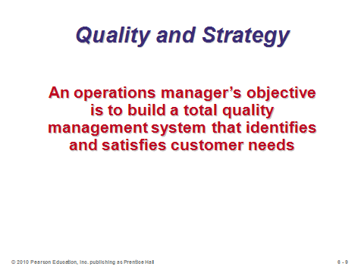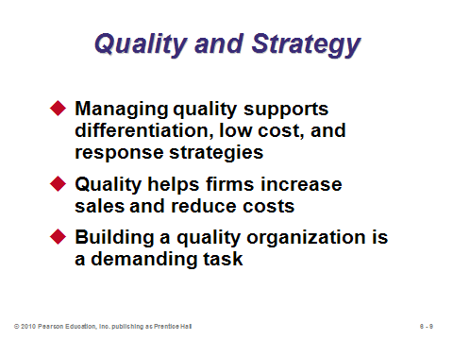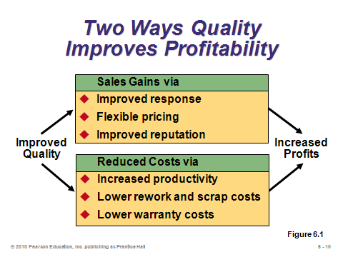

**6-9 6-10 6-11**

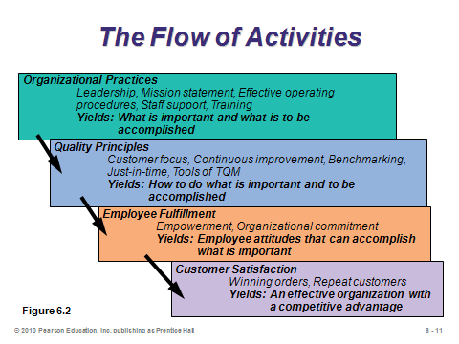

**6-12**

DEFINING QUALITY (6-13 through 6-23)

Slides 13-16: Quality means different things to different people for different products and services under different circumstances. It all begins with a good understanding of what the customers expect. Slide 13 is particularly important to emphasize. High quality does so much more than just reduce rework costs. The reputation implications can have a huge impact on profitability, and it is so difficult to recover from bad publicity about quality. Furthermore, several firms over the past few years have gone bankrupt due to liability stemming from product defects.

Slides 17-18: Instructors can spend several minutes on the Baldrige Award if they want to. Video clips of awards presentations can be shown, which usually include a U.S. President or Vice President. Also, the web site contains a lot more information about the award, and it can be interesting to look at all the past winners—some are well known while many others are not. It can be useful to emphasize that some firms apply for the award with no intention of winning it—they want the quality audit to show them needed areas of improvement.

Slides 20-21: Here’s where the concept of making it “right the first time” can be emphasized. Spending more on prevention usually leads to bigger savings in failure costs and potentially even appraisal costs. In particular, external failure costs may exceed the price of the final product itself and can be devastating in terms of company reputation. The old carpenter’s quote applies here, “Measure twice and cut once.”

Slide 22: This slide shows some of the pioneers of quality management. Deming was probably the most influential. In fact, the Japanese honor Deming by naming their top national quality prize after him (an American). An interesting film about Deming was produced that shows him in action later in life. Both he and Juran were not particularly charismatic. Crosby, on the other hand, displayed his charisma like an infomercial professional (in a generally positive way). Crosby definitely focused less on the quantitative aspects of TQM than the other pioneers. One important way that Juran differed was with the idea of choosing a defect level (which could be less than 1%) that minimized the “cost of quality” (finding the balance between prevention and failure costs). Deming and Crosby, on the other hand, preached about striving for and attaining zero defects.

Slide 23: The point about responding to problems is particularly important. Mistakes happen, but how does an ethical company respond and make it right?

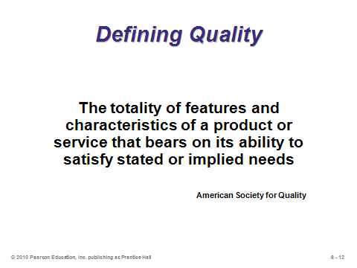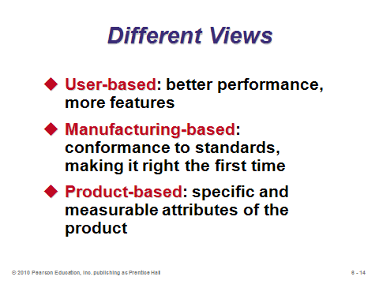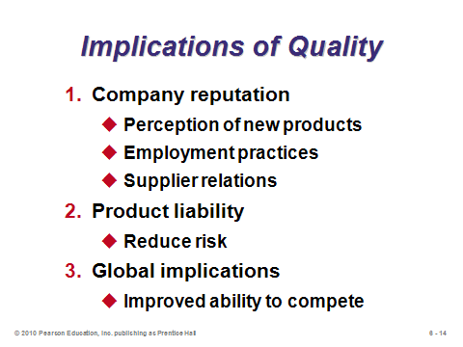

**6-13 6-14 6-15**

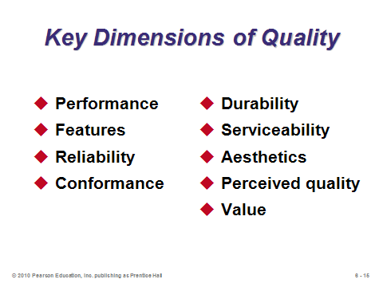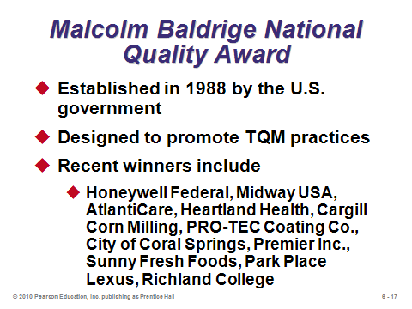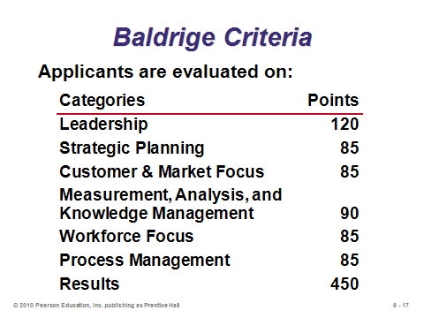

**6-16 6-17 6-18**

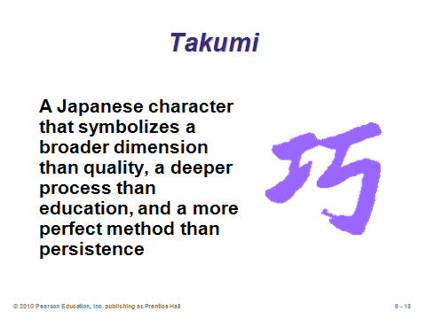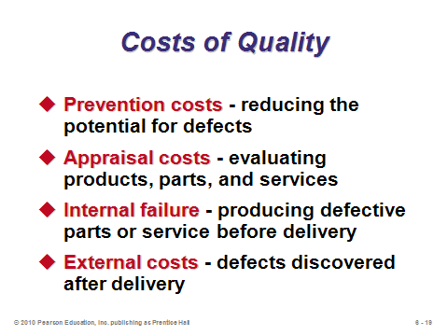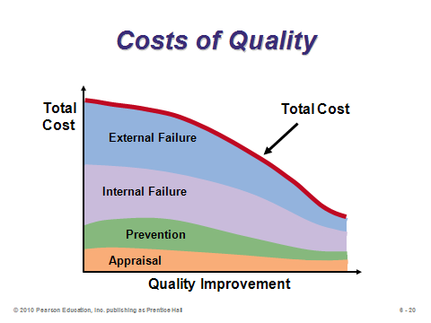

**6-19 6-20 6-21**

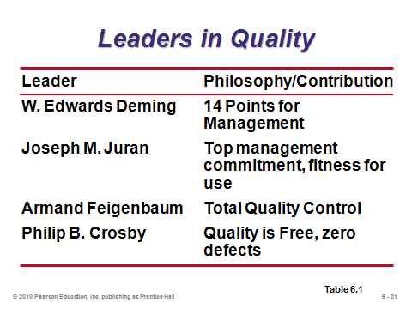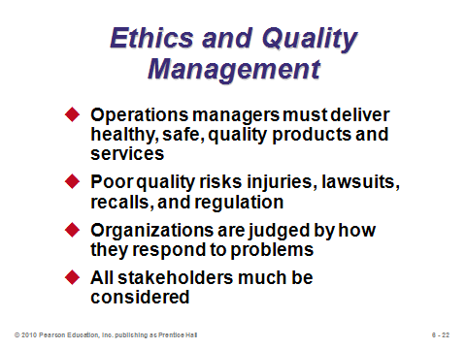

**6-22 6-23**

INTERNATIONAL QUALITY STANDARDS (6-24 through 6-26)

Slide 24: ISO 9000 continues to be an important standard around the world, and increasingly in the United States. Many overseas companies will not purchase from suppliers who are not ISO 9000 certified. It used to be easier to make jokes about ISO 9000, because the original standards focused on documentation and consistency, with little stated about quality itself. However, recent updates to the standards have emphasized more features similar to the Baldrige criteria. An important advantage of a certification like ISO 9000 is that firms can rely on such a certification as an outside validation of quality—this frees firms from having to audit each potential supplier for themselves.

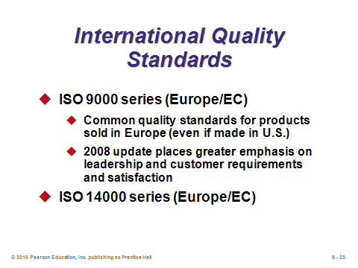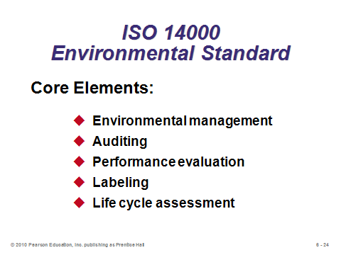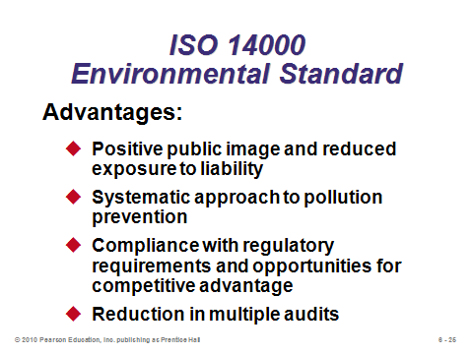

**6-24 6-25 6-26**

TOTAL QUALITY MANAGEMENT (6-27 through 6-50)

Slide 27: It can be re-emphasized here that TQM programs are difficult to implement and represent a cultural change that must be supported in words *and actions* by top management.

Slides 28-30: Deming’s points represent one framework to think about implementing a TQM program.

Slides 32-33: Continuous improvement is like a race with no finish line. The runner can celebrate and take a break now and then, but then she needs to get back on that road and keep going further. The most important feature of the PDCA cycle is the arrow on top—showing that the cycle does not end with implementation but starts again with a new set of improvements.

Slides 34-38: In some ways, Six Sigma is modern re-wording of old TQM concepts. The Six Sigma certification program (black belts and green belts) has become highly valued for those that attain the certification. In some ways, it is quality management’s equivalent to the CPA in accounting or the CFA in finance. A nice feature of the certifications is that they involve not only passing exams, but also real-world experience in management quality improvement projects.

Slides 39-40: Arguably, employee empowerment represents the most powerful means to improve quality in an organization. Often the people closest to the actual work know best how to improve it. A key feature for success is to properly reward employees for helping to improve quality.

Slide 41: Note that benchmarking does not have to examine only other firms in the industry. World-class organizations from other industries lead to some great ideas—and those companies might be more willing to share information.

Slide 42: This is a very nice slide to cover point-by-point. Proper complaint resolution has such a huge impact on company reputation.

Slides 43-46: JIT receives much fuller treatment in Chapter 16. The issues here are that JIT in the form of “procrastination” has two main benefits: less inventory and identification of errors early before they are applied to many products. The boat slides represent a key description of the Japanese philosophy. Inventory (the water) acts as a band-aid, potentially helping for “smooth sailing” in the short run but actually hiding root problems in the long run. The Japanese suggest that the better approach is to throw the band-aids away and force yourself to bleed (hit the rocks). Only then will you truly identify the root problems, which then can be eliminated. Once the root problems are gone, the need for the band-aids (the inventory) disappears.

Slides 49-50: A study found that U.S. consumers preferred Sony TVs made in Japan to those made in the U.S. Both factories used the same designs and specifications. But the difference in quality goals led to the difference in consumer preferences. Specifically, the U.S. factory had output that was uniformly distributed between the upper and lower specification limits. The Japanese factory, however, had output centered around the target in the shape of a normal distribution. Thus, much more of its output was near the target (or the center of the upper and lower limits). Clearly, this target-oriented approach led to higher quality final products. Why? Imagine many slightly large bolts fitting into slightly small nuts (connections that are too tight) and other slightly small bolts fitting into slightly large nuts (connections that are too loose). Add all those up over many components in a TV, and more things will go wrong. With the quality loss function, it’s important to emphasize that those are not *actual* costs. A component produced within specs may indeed cost nothing. However, the function is *estimating* the costs of not hitting the target exactly, using the important assumption that the costs increase according to a quadratic function, that is, doubling the distance from the target will quadruple the estimated cost. One application of the quality loss function could be in determining whether or not to buy a new machine that produces output closer to the target. Even if both the new and old machines always produce within spec limits, presumably the accuracy provided by the new machine has some benefits, which can be quantified by using quality loss function estimates.

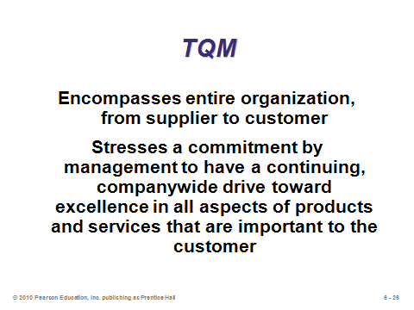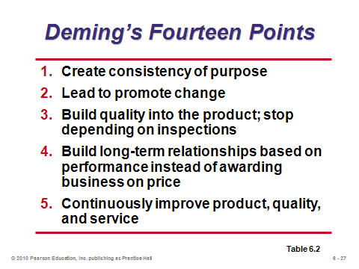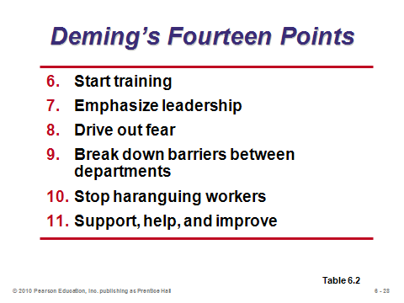

**6-27 6-28 6-29**

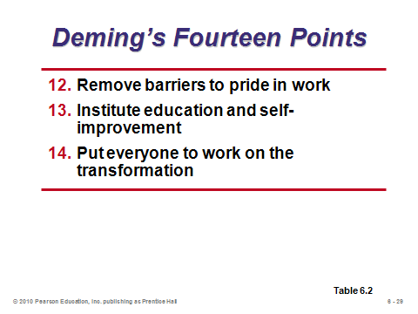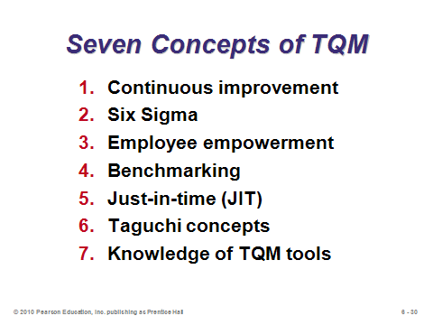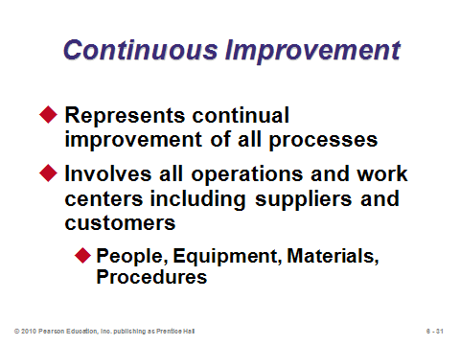

**6-30 6-31 6-32**

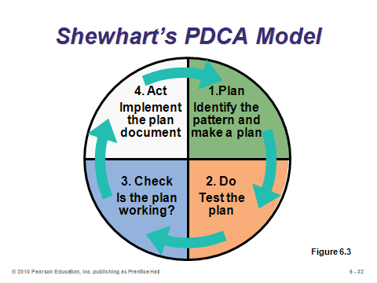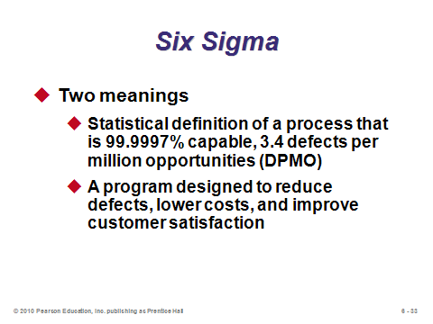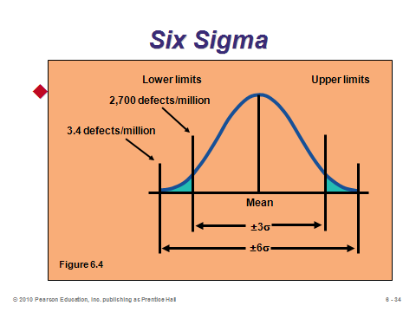

**6-33 6-34 6-35**

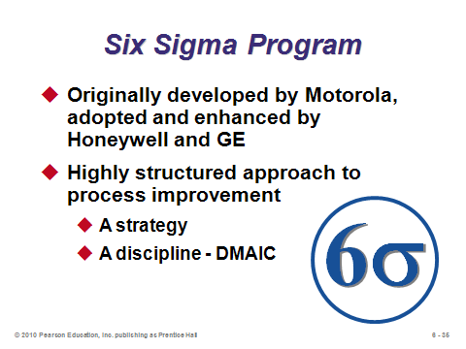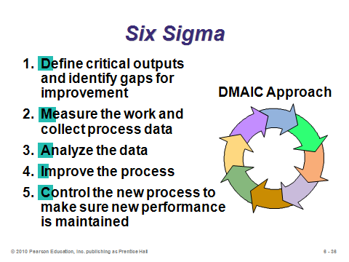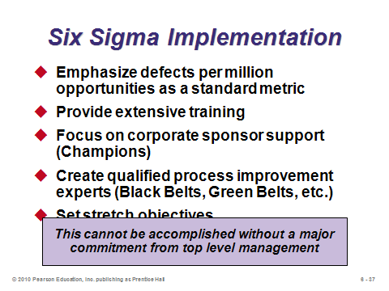

**6-36 6-37 6-38**

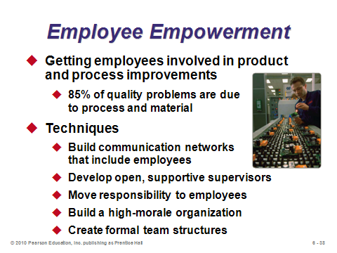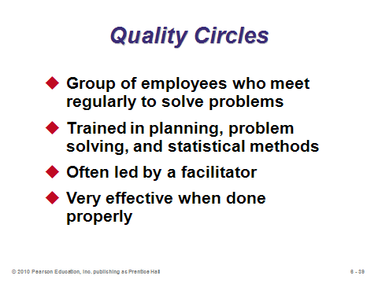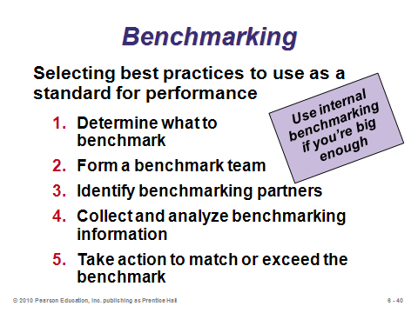

**6-39 6-40 6-41**

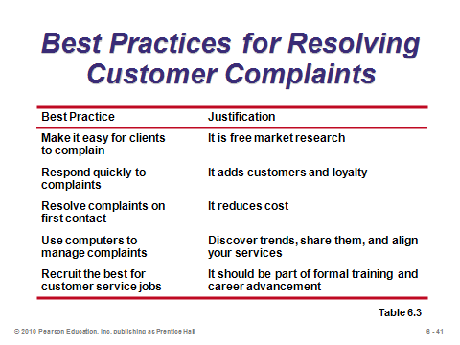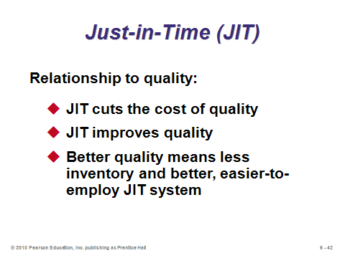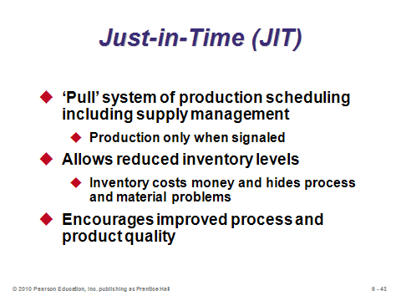

**6-42 6-43 6-44**

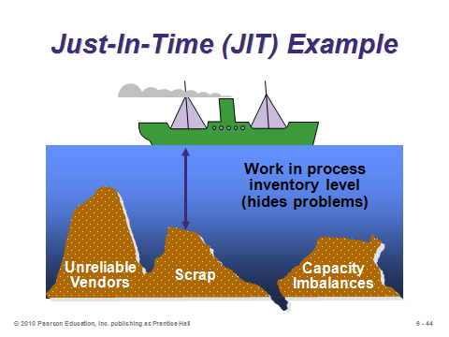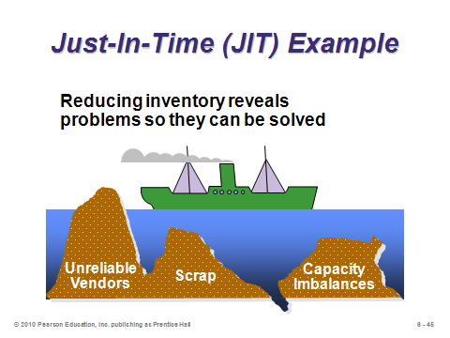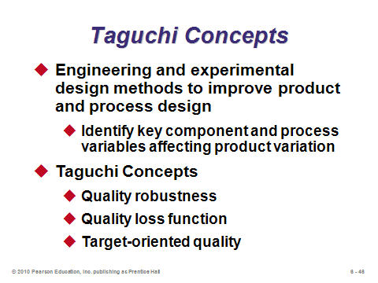

**6-45 6-46 6-47**

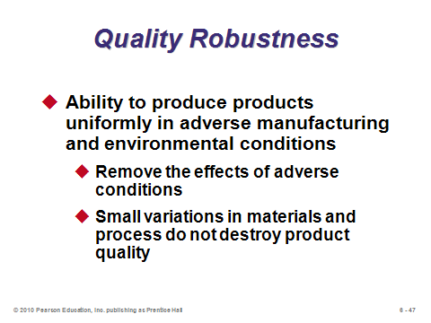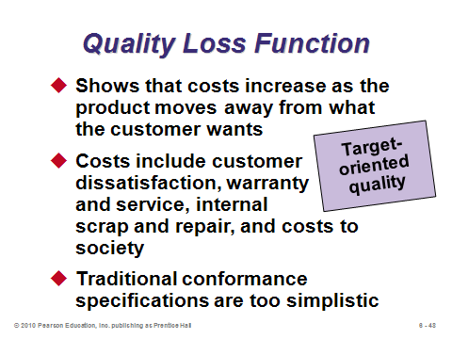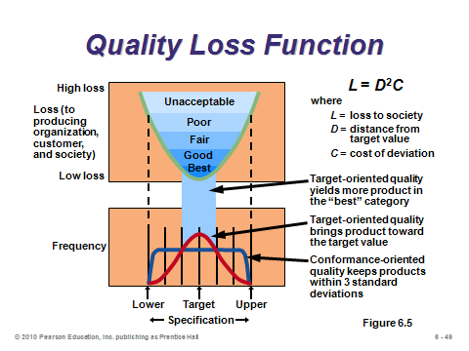

**6-48 6-49 6-50**

TOOLS OF TQM (6-51 through 6-64)

Slides 51-64: These are nice graphics that illustrate the seven tools. The full set can be covered relatively quickly. The first six, at least, are among the easier quantitative methods that operations managers employ; nevertheless, they can provide powerful insight.

Slide 53: A check sheet can have a variety of appearances. In many cases, patterns are easily seen while the data are being taken.

Slide 54: With a scatter diagram, if the two items are closely related, the data points will from a tight band. If a random pattern results, the items are unrelated.

Slide 55: The cause-and-effect diagram is also called a fishbone or Ishikawa diagram. The four Ms can be a good starting point for main causes. The lecture could break at this point with an example having students fill in the diagram with ideas of causes of some outcome.

Slide 56: A Pareto chart exhibits the natural phenomenon that, in general, 80% of problems are a result of only 20% of causes. The lecture could break here by asking the students about their experience managing things. Did the Pareto rule apply?

Slide 57: A picture can truly be worth 1000 words when attempting to analyze a process. A flow chart provides such a picture.

Slide 58: A histogram can help determine the potential actual underlying distribution of a variable. If it looks like a bell curve, the distribution might be Normal; if it looks like a rectangle, the distribution might be uniform, etc. More generally, a histogram, provides a quick visual estimate of the mean, mode, skewness, etc.

Slide 59: SPC charts are the most “scientific” of the quality tools. They are covered in detail in Supplement 6. They are used to monitor a process over time. When output falls outside the control limits, the process should be investigated to search for an unnatural (assignable) cause.

Slides 60-64: These provide further examples of some of the seven tools. They can be placed after each respective tool, if desired.

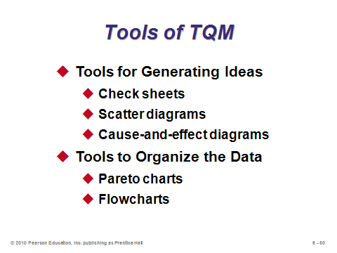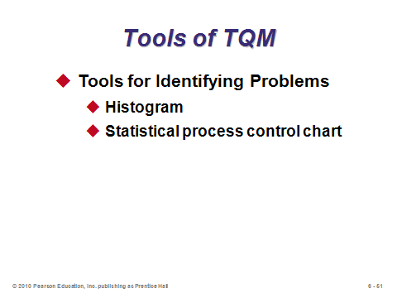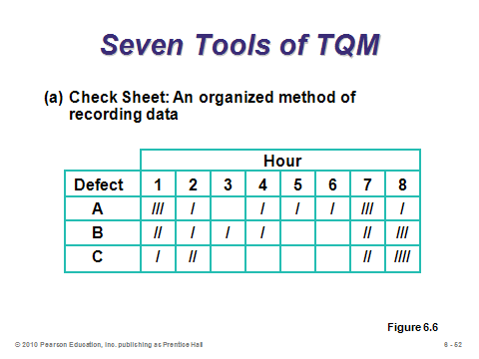

**6-51 6-52 6-53**

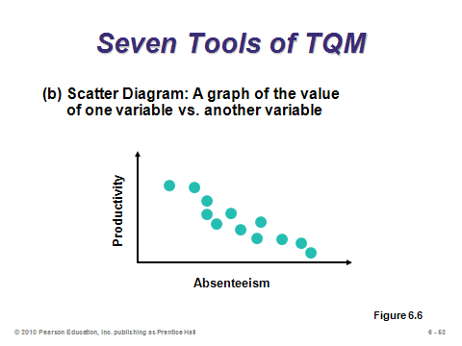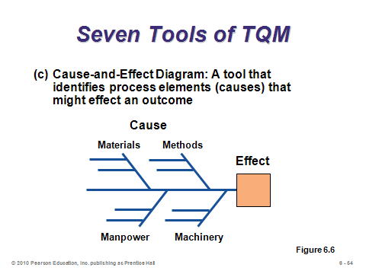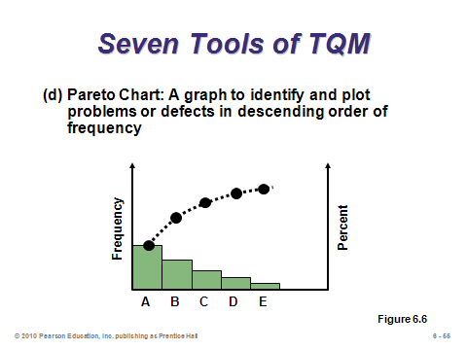

**6-54 6-55 6-56**

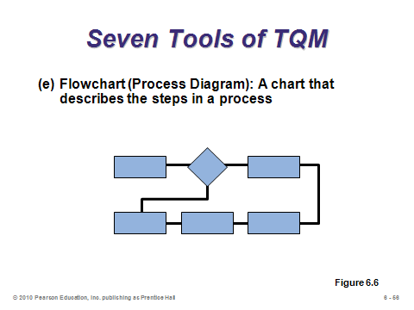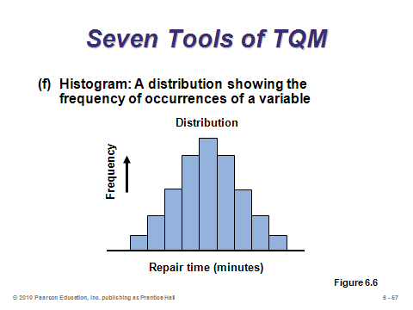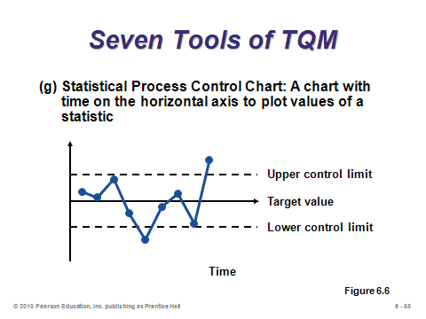

**6-57 6-58 6-59**

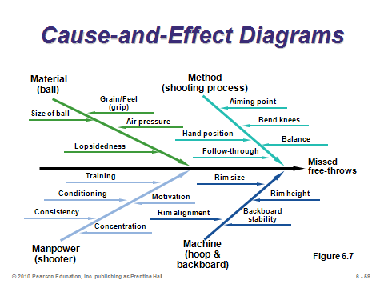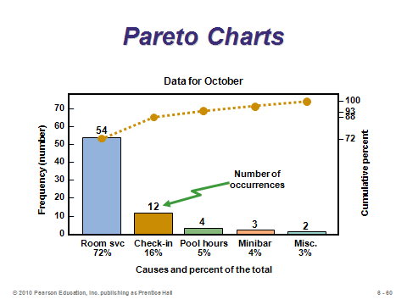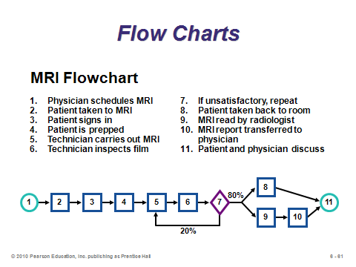

**6-60 6-61 6-62**

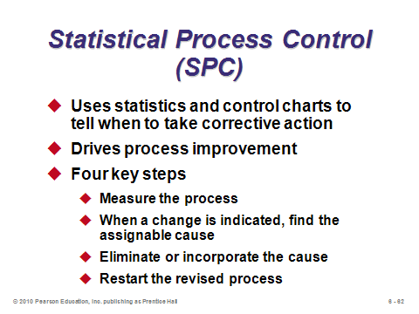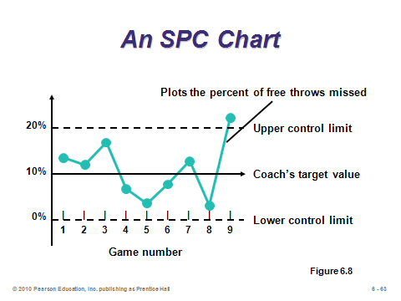

**6-63 6-64**

THE ROLE OF INSPECTION (6-65 through 6-74)

Slides 65-68: In the old days, the only form of quality management implemented by companies was the process of inspection. Inspection itself may not catch all errors, and it may be costly. Ideally, suppliers are delivering perfect materials and products are made right the first time, which would minimize the need for a lot of inspection. “Source inspection” is the concept of controlling or monitoring at the point of production or purchase. This is consistent with the idea of employee empowerment, where individual employees self-check their own work. If done correctly, source inspection would eliminate the need for extra inspections anywhere else. If inspections are needed, slide 66 provides the common places. Point 3 is probably the most important because sending a defective product through the bottleneck process reduces the throughput for the entire operation.

Slides 69-73: These provide service industry inspection examples from Table 6.4 in the text. Clearly, inspection can be as important in services as in manufacturing.

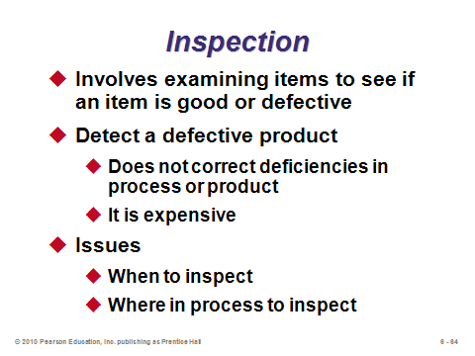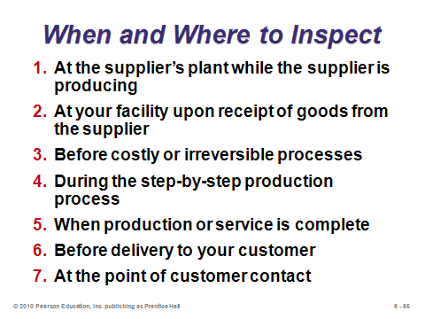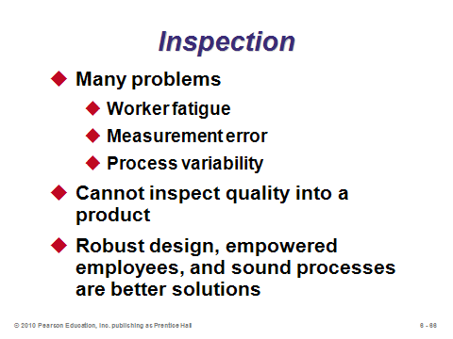

**6-65 6-66 6-67**

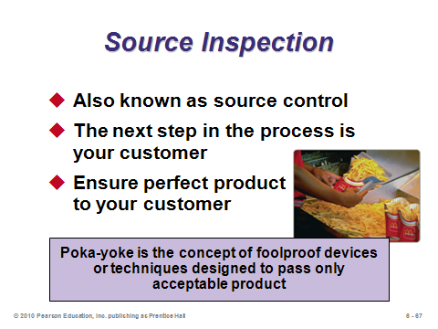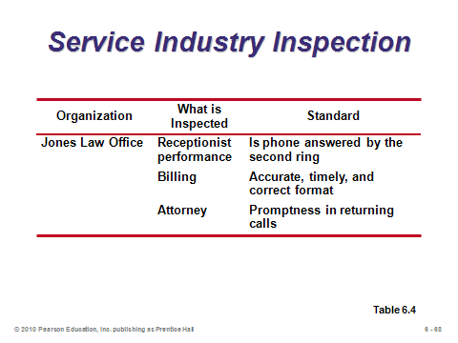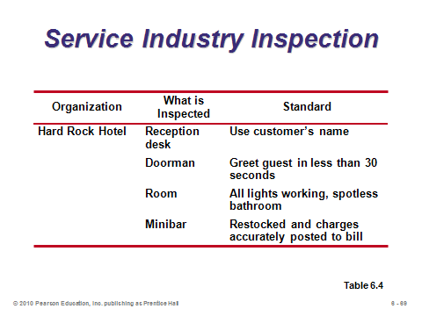

**6-68 6-69 6-70**

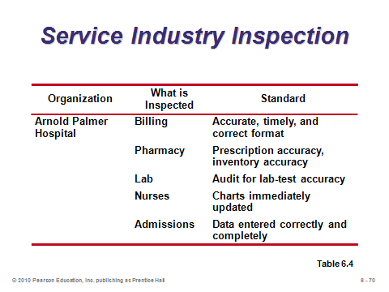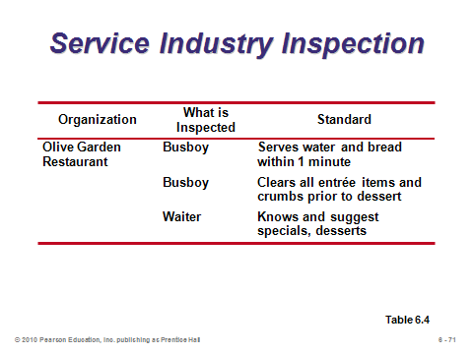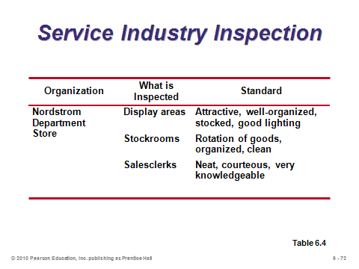

**6-71 6-72 6-73**

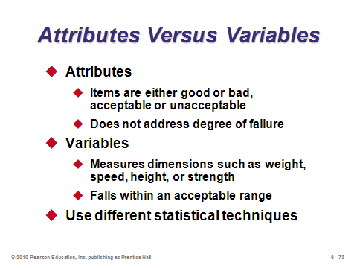

**6-74**

TQM IN SERVICES (6-75 through 6-79)

Slides 75-79: These slides focus on the special challenges and differences that attempting to implement TQM in services has. The UPS example in Slide 77 is common in many service businesses, where employee appearance matters because there is customer contact. Disney World has similar standards for its student workers. You won’t find your ride operator sporting facial piercing and visible tattoos at Disney World. Slide 78 illustrates some of the different points of emphasis with respect to quality that service firms must adhere to. Finally, Slide 79 shows that Marriot’s LEARN routine is a nice way to think about service recovery. Each component is important, but the last one in particular notifies the system about the problem in the hopes that similar problems will not occur in the future.

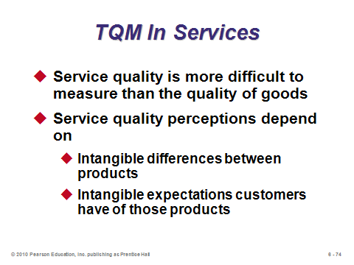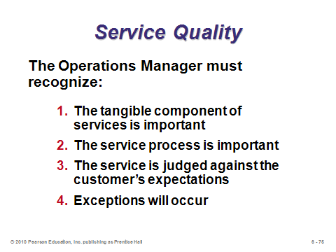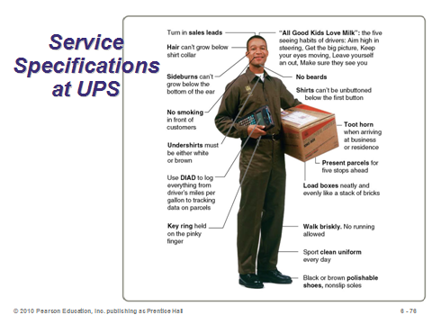

**6-75 6-76 6-77**

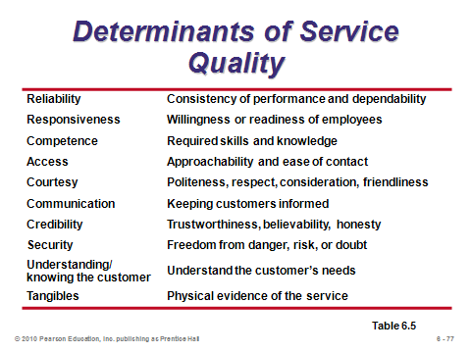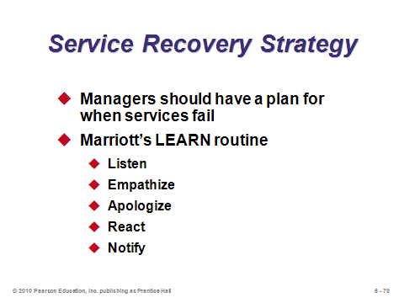

**6-78 6-79**

**Additional Assignment Ideas**

1. Use the QFD house of quality as a project. Students, (usually as a team) choose a product (good or service) and do a house of quality analysis, including comparison and market research segments. Add as many aspects as you like to make it a minor or major project. Have students explain the analysis to the class. This can be expanded to an implementation of the process to show how each subsequent phase would be accomplished.

2. Research the *six sigma* certifications from the American Society for Quality. Specifically, identify several specific items that appear on the exam that are not covered in Chapter 6 of the textbook. Write a paragraph or two describing each item.

3. Find out more about ISO 9000 from the web (http://www.iso.ch). What is ISO? What are the benefits of international standardization? How have the ISO 9000 standards been received worldwide?

**Additional Case Studies**

Internet Case Study (www.pearsonglobaleditions.com/heizer)

* *Westover Electrical, Inc*.: This electric motor manufacturer has a large log of defects in its writing process.

Harvard Case Studies (http://harvardbusinessonline.hbsp.harvard.edu)

* *GE: We Bring Good Things to Life (A)* (#899-162) Illustrates the complexity of managing change and the momentum that initiatives can provide.
* *Wainwright Industries (A): Beyond the Baldrige* (#396-219): Traces the growth of an auto supply company and its culture of quality.
* *Romeo Engine Plant* (#197-100): The employees at this auto engine plant must solve problems and ensure quality, not watch parts being made.
* *Motorola-Penang* (#494-135): The female manager of this Malaysia factory is skeptical of empowerment efforts at other Motorola sites.
* *Measure of Delight: The Pursuit of Quality at AT&T Universal Card Service (A)* (#694-047): Links performance measurement and compensation policies to precepts of Quality management.

Richard Ivey School of Business (http://cases.ivey.uwo.ca/cases/pages/home.aspx)

* *Six Sigma Implementation at Maple Leaf Foods* (#9B05D016): Six Sigma has become a popular management philosophy adopted by several large companies including Maple Leaf Foods as a means of reducing waste systematically. Students will develop a deeper understanding of Six Sigma and the challenges associated with embedding it in the organization.

**Internet Resources**

|  |  |
| --- | --- |
| American Society for Quality | www.asq.org |
| ISO Central Secretariat | www.iso.ch |
| Juran Institute | www.juran.com |
| Links to Benchmarking Sites | www.ebenchmarking.com |
| National Institute of Standards and Technology | www.quality.nist.gov |
| Quality Assurance Institute | www.qaiworldwide.org |
| Quality Digest | www.qualitydigest.com |
| Quality Progress | www.qualityprogress.asq.org |

**Other Supplementary Material**

Videos

*1. Big Night*: Italian immigrant chef maintains classic values of his cuisine, despite the voice of the customer. Topic: Voice of the customer vs. voice of the designer.

2. *Brazil*: Argument with bureaucrat. Topic: Service quality

3. *Falling Down*: Michael Douglas loses it as he orders breakfast in a fast food restaurant. Topics: Service quality; customer service.

4. *Five Easy Pieces*: Restaurant scene. Topic: Service Quality.

5. Films available from:

Society of Manufacturing Engineers

One SME Drive

P.O. Box 930

Dearborn, Michigan 48121-0930

(P) 313-425-3000

(F) 313-425-3412

http://www.sme.org

* *Implementing QS-900O*-Gain a powerful advantage in meeting demanding QS-9000 standards. Order # PI-VT569-3456
* *Mistake Proofing: Achieving Zero Defects*-Exploring how poka-yoke is being implemented and in what direction it is leading manufacturing. Order # PI-VT616-3456
* *Total Quality Management: Creating a Culture of Continuous Improvement*-Explore the ongoing development of TQM once a company has laid the critical groundwork. Order # PT-VT501-3456